Lab Manual for Software Construction and Development – SESD3241
Practice Lab 03-Spring 2026

Lab Manual
SCD LAB Booklet



Faculty of Information Technology
UCP Lahore Pakistan



University of Central Punjab
Faculty of Information Technology

PROGRAM (S) TO BE
EVALUATED
- Course Description
Course Code | SESD 3241
Course Title | Software Construction & Development (Lab)
Credit Hours | 0-1
Semester | Spring, 2026

Objective: Understand Agile principles and Scrum framework.

Agile Project:
An Agile project is a project managed using Agile methodologies that prioritize flexibility, collaboration, and iterative development. Unlike traditional project management (like Waterfall), which follows a linear, sequential approach, Agile project management is adaptive, allowing teams to respond to change more efficiently.
Sprints:
Agile projects are typically broken down into small, manageable units of work that are delivered in short, iterative cycles called sprints.
Agile Principles:
Agile principles are the foundational ideas that guide teams and organizations in Agile project management and software development. Our highest priority is to satisfy the customer through the early and continuous delivery of valuable software.
Common Agile Methodologies Used in Projects is Scrum.
Scrum:
- Scrum is one of the most widely used frameworks in Agile projects. It focuses on delivering work in sprints with clearly defined roles like Scrum Master, Product Owner, and Development Team.
- Teams hold daily stand-up meetings to discuss progress and blockers and track tasks on a Scrum board.
- Each sprint culminates in a Sprint Review (for stakeholder feedback) and a Sprint Retrospective (to improve team processes).

Example Task:
Software Project Overview: Learning Management System (LMS)
Objective: Develop an LMS that allows educators to create and manage courses, students to enroll and track progress, and facilitate interaction through assignments, quizzes, and discussion forums.
Create a New Project
Figure 1
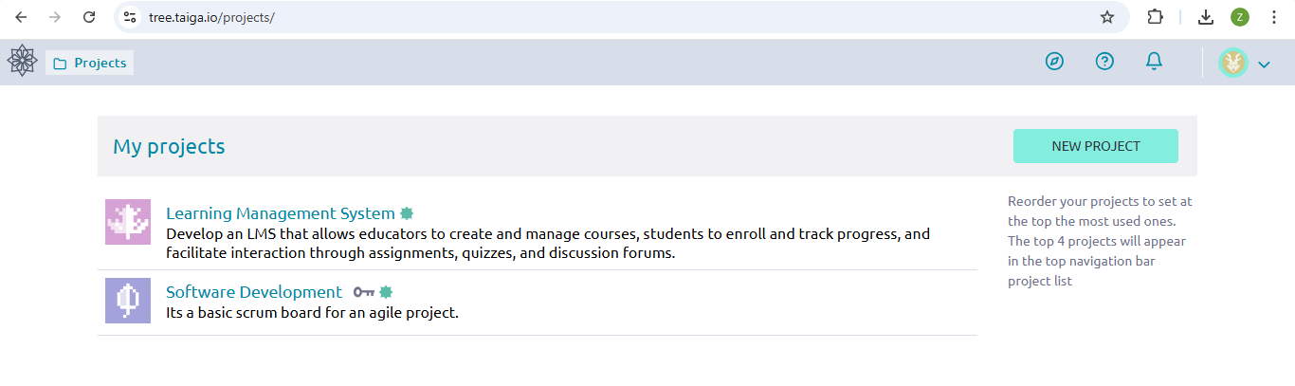

Sample User Stories:
- Course Creation & Management (Instructor)
  - As an instructor, I want to create a course, so that students can enroll and access my course materials.
  - As an instructor, I want to upload resources (PDFs, videos), so that students can access study materials.
- Student Enrollment & Progress Tracking
  - As a student, I want to search for courses, so that I can find relevant ones to enroll in.
  - As a student, I want to track my progress in the course, so I can see my completed modules and assignments.
- Assignments & Quizzes
  - As an instructor, I want to create assignments and quizzes, so students can submit their work and get assessed.
  - As a student, I want to submit assignments and take quizzes, so I can complete course requirements.

Create User Stories: Define LMS features like Course Creation, Student Enrollment, Assignments.
Figure 2
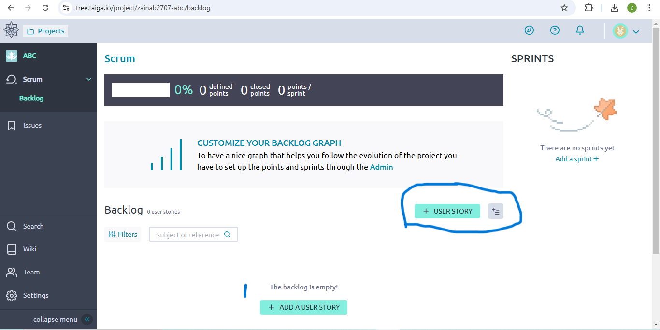Figure 3
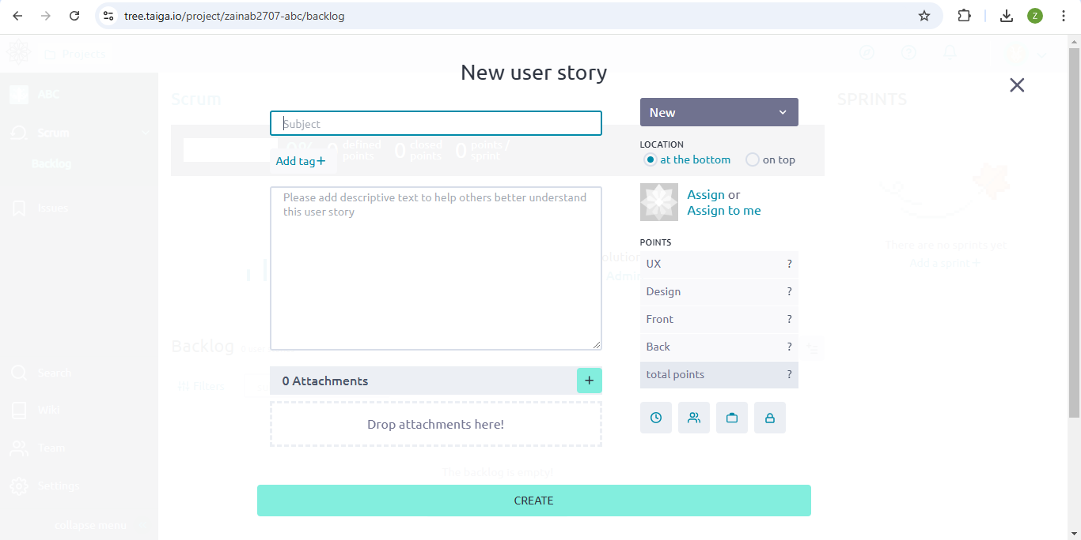

Add Tasks to User Stories:
Figure 4
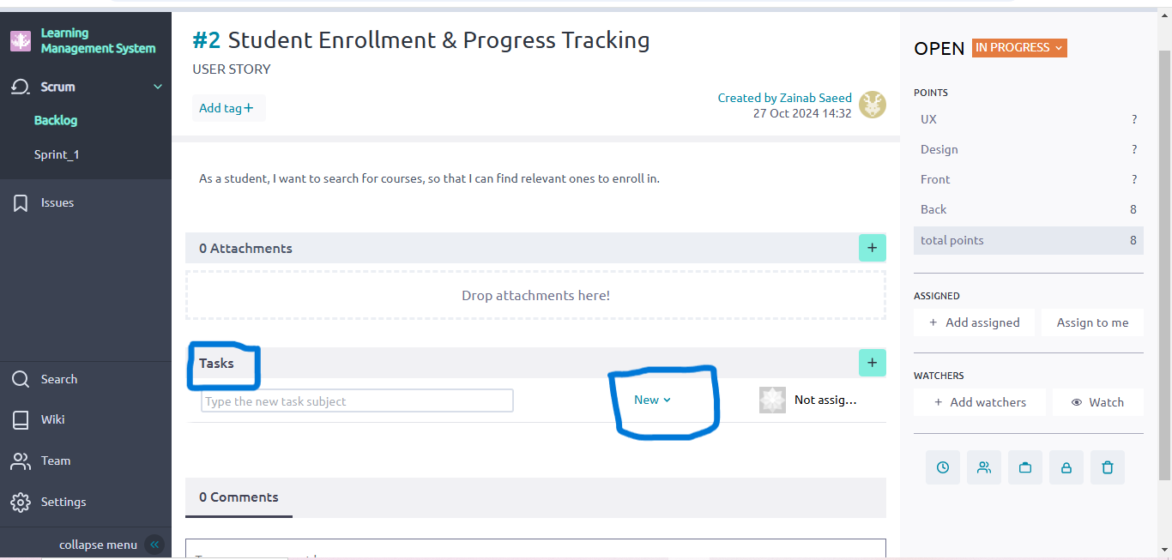
Sprint 1: Student Enrollment & Progress Tracking
- Task: Develop Course Search Functionality
- Description: Create a search bar to allow students to search for courses by title, instructor, or category.
- Story Points: 3
- Priority: High
- Status: To Do
- Assignee: Front-End Developer
- Task: Implement Student Enrollment Process
- Description: Develop functionality for students to enroll in courses and save the data in the database.
- Story Points: 5
- Priority: High
- Status: To Do
- Assignee: Back-End Developer
- Task: Track Course Progress for Students
- Description: Implement the back-end logic to track the student's completion of course modules, assignments, and quizzes.
- Story Points: 4
- Priority: Medium
- Status: To Do
- Assignee: Full Stack Developer
- Task: Test Enrollment and Progress Tracking
- Description: Perform QA testing to ensure smooth enrollment and accurate progress tracking.
- Story Points: 2
- Priority: High
- Status: To Do
- Assignee: QA Tester
Create a Sprint:
Figure 5

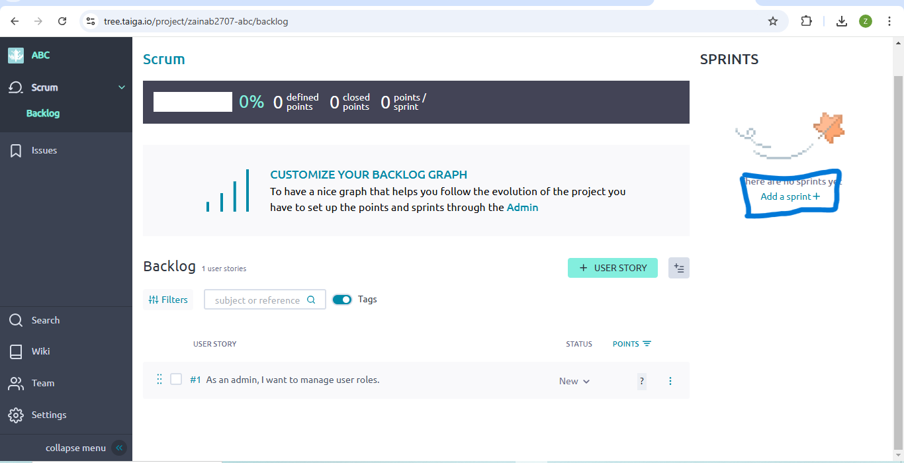

Figure 6
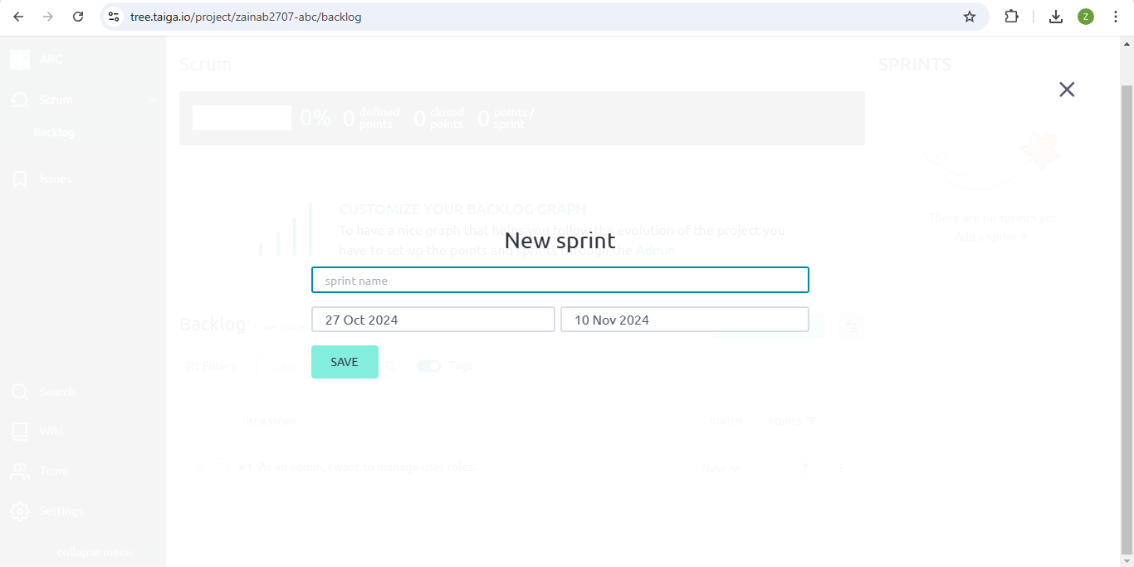
Track Task Progress: Move tasks across columns (To Do, In Progress, Done).
Figure 7
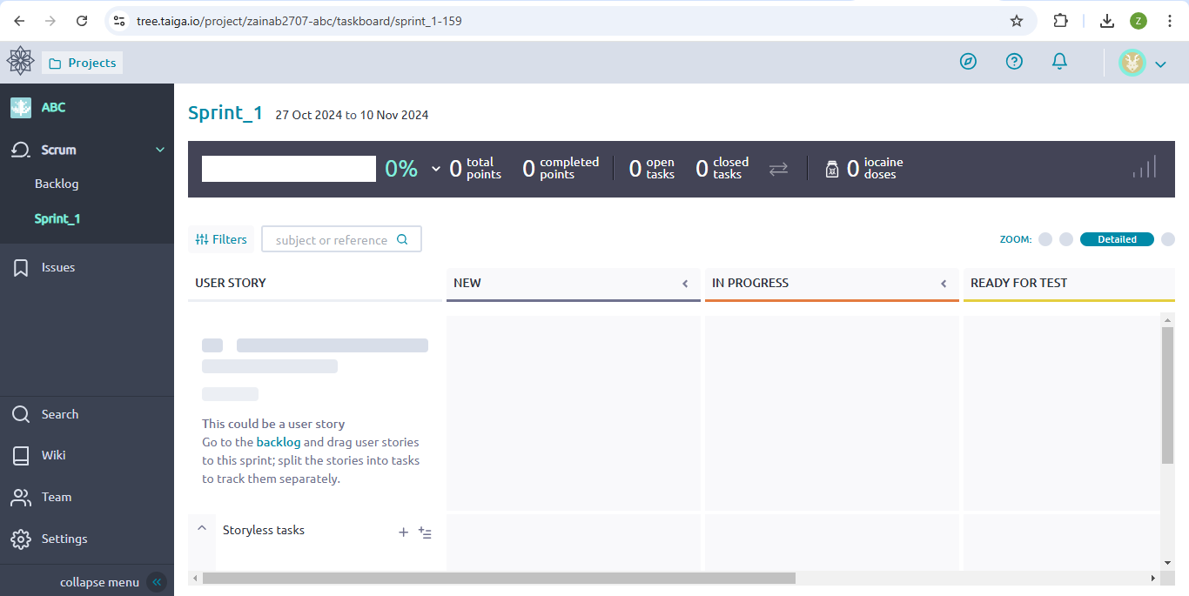
Figure 8
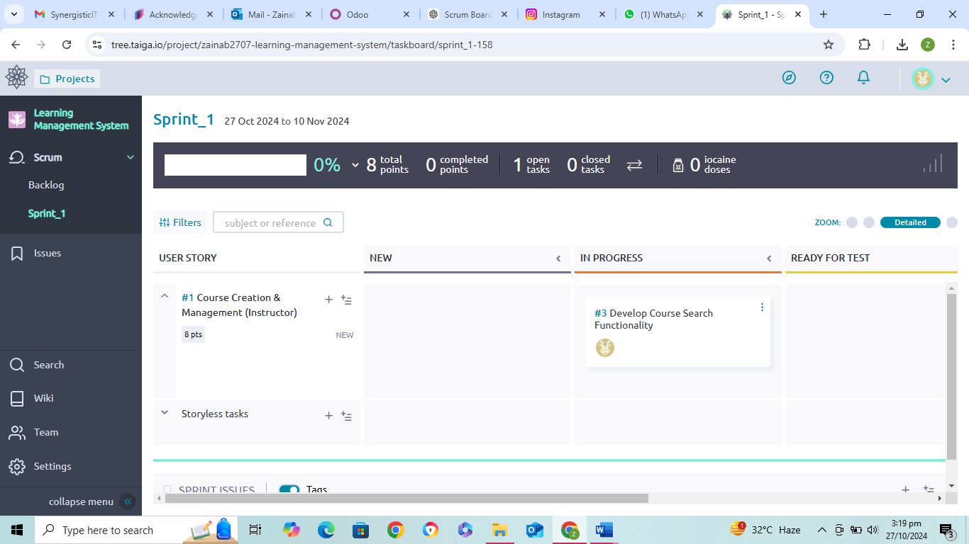
Practical Lab Question 3: Agile Process and Scrum Workflow
- Objective: Understand Agile principles and Scrum framework.
- Tasks:
- Create a Scrum board using Jira or Trello. (Since Jira and Trello are not free tools, we will use Taiga instead.)

Set up tasks for a Software Project E-Commerce Website Development (user stories, sprints).
Objective: Develop an e-commerce platform with key features such as product browsing, user registration, shopping cart, order management, and payment processing.
Sample User Stories:
- User Authentication & Registration
- As a user, I want to create an account, so that I can log in and access personalized features.
- As a user, I want to reset my password, so I can regain access to my account if I forget it.
- Product Catalog
- As a user, I want to browse a list of products, so I can find items to purchase.
- As a user, I want to filter products by price and category, so I can easily find what I am looking for.
- Shopping Cart
- As a user, I want to add items to a shopping cart, so I can purchase multiple items at once.
- As a user, I want to remove items from my cart, so I can adjust my purchase before checking out.
- Order Management
- As a user, I want to view my order history, so I can see details of my previous purchases.
- As a user, I want to track the status of my order, so I know when it will arrive.
- Payment Integration
- As a user, I want to securely pay for my items using a credit card or digital payment methods, so I can complete my purchase.
Each user story is broken down into tasks and subtasks that will be added to the Scrum board.
Sprint 1: User Authentication & Registration
- Task: Design User Registration Form
- Description: Create the front-end form for user registration.
- Story Points: 3
- Priority: High
- Status: To Do
- Assignee: Front-End Developer
- Task: Implement User Authentication API
- Description: Develop back-end API for user login and authentication using JWT.
- Story Points: 5
- Priority: High
- Status: In Progress
- Assignee: Back-End Developer
- Task: Reset Password Functionality
- Description: Develop the functionality to reset user passwords via email verification.
- Story Points: 3
- Priority: Medium
- Status: To Do
- Assignee: Full Stack Developer
- Task: Test User Authentication
- Description: Perform unit and integration tests to ensure proper authentication flow.
- Story Points: 2
- Priority: High
- Status: To Do
- Assignee: QA Tester

Sprint 2: Product Catalog & Browsing
- Task: Create Product Listing Page
- Description: Design the page layout for displaying products, including thumbnails, titles, prices, and a brief description.
- Story Points: 3
- Priority: High
- Status: To Do
- Assignee: UI/UX Designer
- Task: Implement Product Catalog API
- Description: Create the API endpoint to fetch and display product data from the database.
- Story Points: 4
- Priority: High
- Status: To Do
- Assignee: Back-End Developer
- Task: Add Filtering and Sorting Functionality
- Description: Add product filtering (by category, price range) and sorting (by price, popularity).
- Story Points: 5
- Priority: Medium
- Status: To Do
- Assignee: Full Stack Developer
- Task: Integrate Search Bar
- Description: Implement a search bar to allow users to search for products by name or description.
- Story Points: 3
- Priority: Medium
- Status: To Do
- Assignee: Front-End Developer

Sprint 3: Shopping Cart & Checkout
- Task: Develop Shopping Cart Interface
- Description: Create the front-end interface for adding and removing items from the shopping cart.
- Story Points: 4
- Priority: High
- Status: To Do
- Assignee: Front-End Developer
- Task: Implement Shopping Cart Backend
- Description: Develop the back-end logic for storing and managing shopping cart data, such as items, quantities, and total cost.
- Story Points: 5
- Priority: High
- Status: To Do
- Assignee: Back-End Developer
- Task: Validate Checkout Process
- Description: Ensure that the checkout process, including billing and shipping details, is functional and secure.
- Story Points: 4
- Priority: High
- Status: To Do
- Assignee: QA Tester
- Task: Integrate Payment Gateway
- Description: Implement payment gateway integration (e.g., Stripe, PayPal) for processing payments.
- Story Points: 6
- Priority: High
- Status: To Do
- Assignee: Full Stack Developer

Sprint 4: Order Management & History
- Task: Create Order History Page
- Description: Develop a user interface to display past orders, including item details, dates, and status.
- Story Points: 3
- Priority: Medium
- Status: To Do
- Assignee: Front-End Developer
- Task: Implement Order Management API
- Description: Create the back-end API to retrieve order details from the database.
- Story Points: 4
- Priority: Medium
- Status: To Do
- Assignee: Back-End Developer
- Task: Set Up Order Tracking System
- Description: Implement a system to track order status (e.g., processing, shipped, delivered).
- Story Points: 4
- Priority: Medium
- Status: To Do
- Assignee: Full Stack Developer

Sample Scrum Board for Sprint 1:
Task | Assignee | Status | Story Points | Priority
Design User Registration Form | Front-End Developer | In Progress | 3 | High
Implement User Authentication API | Back-End Developer | To Do | 5 | High
Reset Password Functionality | Full Stack Developer | To Do | 3 | Medium
Test User Authentication | QA Tester | To Do | 2 | High

